WHAT IS APACHE AIRFLOW
Apache Airflow is an open-source platform used to programmatically author, schedule, and monitor workflows. Created by Maxime Beauchemin at Airbnb in 2014, open-sourced in 2015, and became a top-level Apache Software Foundation project in 2019. Used by thousands of companies worldwide including Google, Twitter, LinkedIn, and Walmart.
The core idea is simple — define your workflows as code. This makes them maintainable, testable, version-controlled, and collaborative. Airflow does not move or process data itself. It orchestrates other tools and systems, acting like a conductor telling each instrument when to play.

1. CORE CONCEPTS
DAG (Directed Acyclic Graph) The most fundamental concept in Airflow. A DAG is a Python file that describes what tasks need to run, the order they run in, and how often. Directed means tasks flow in one direction. Acyclic means no loops. Graph means it is a network of connected nodes.
Tasks The basic unit of execution. Each node in a DAG is a task. Tasks can succeed, fail, be retried, or be skipped. Task states include queued, running, success, failed, skipped, and retry.
Operators Operators define what a task actually does. Common ones include:
- PythonOperator — runs a Python function
- BashOperator — runs a shell command
- EmailOperator — sends emails
- HttpOperator — makes API calls
- PostgresOperator / MySqlOperator — runs SQL queries
- S3Operator / GCSOperator — interacts with cloud storage
- BranchPythonOperator — conditional logic, chooses which task runs next
- DummyOperator — placeholder, does nothing, used for grouping
Sensors A special type of operator that waits for a condition to become true before moving on.
- FileSensor — waits for a file to appear in a directory
- S3KeySensor — waits for a file to land in an S3 bucket
- HttpSensor — waits for an API endpoint to return success
- ExternalTaskSensor — waits for another DAG to finish
Hooks Interfaces to external systems. They handle connections and authentication behind the scenes. Operators use hooks internally to talk to databases, APIs, and cloud platforms.
Connections Store credentials for external systems — host, port, username, password. Managed through the Airflow UI or environment variables.
Variables Simple key-value pairs stored in Airflow, used across multiple DAGs for configuration purposes.
XComs (Cross-Communications) Allow tasks to share small pieces of data with each other. One task pushes a value, another task pulls it. Meant for small data only — for large datasets use external storage like S3 or a database.

2. ARCHITECTURE
Web Server A Flask-based dashboard where you can view and manage DAGs, monitor task states, check logs, trigger runs manually, and manage connections and variables.
Scheduler The heart of Airflow. Runs as a background process, continuously monitors all DAGs, determines which tasks are ready to run, submits them to the executor, and updates their states in the database.
Executor Determines how and where tasks run.
- SequentialExecutor — one task at a time, testing only
- LocalExecutor — parallel tasks on a single machine, good for small deployments
- CeleryExecutor — distributes tasks across multiple machines via Redis or RabbitMQ, good for large production
- KubernetesExecutor — spins up a Kubernetes pod per task, ideal for cloud-native setups
Metadata Database Usually PostgreSQL or MySQL. Stores everything — DAG definitions, task states and history, connections, variables, XCom values, and user accounts.
Workers Processes that actually execute tasks. In a Celery setup these are separate machines that receive tasks from the message queue and run them.

3. HOW IT WORKS
- You write a Python file defining a DAG with its schedule and tasks
- The Scheduler picks it up from the dags folder and waits for the right time
- When the time comes, tasks are sent to the Executor
- The Executor distributes them to Workers
- Workers run the tasks and report results back to the Metadata Database
- You monitor everything in real time through the Web UI including logs for each task
Task dependencies are defined using the >> operator in Python:
- task1 >> task2 >> task3 means they run one after another
- task1 >> [task2, task3] >> task4 means task2 and task3 run in parallel, then task4 runs after both finish

4. SCHEDULING
Airflow uses cron-style expressions and preset shortcuts:
- @daily — once per day
- @hourly — once per hour
- @weekly — once per week
- @monthly — once per month
- Custom cron like 0 6 * * 1 means every Monday at 6am
The start_date parameter tells Airflow when to begin scheduling. Setting catchup=False tells it not to backfill missed runs from the past.

5. COMMON USE CASES
- ETL Pipelines — extract data from a source, transform it, load it into a data warehouse
- Machine Learning Pipelines — automate model training, validation, and deployment
- Data Warehouse Ingestion — load data from multiple sources into one central place
- Report Generation — automate daily or weekly report creation and distribution
- API Data Collection — pull data from external APIs on a schedule
- Database Maintenance — run cleanup jobs, backups, and migrations automatically
- Monitoring and Alerting — check system health and send alerts if something fails

6. WHY USE AIRFLOW
- Workflows are written in Python giving full programmatic control
- Scalable — handles thousands of tasks across distributed systems
- Hundreds of built-in integrations with AWS, GCP, Azure, databases, and APIs
- Rich UI with logs, task history, and alerting
- Active open-source community with regular updates
- Easy to retry failed tasks with configurable retry logic
- Can run tasks in parallel saving significant time
- Version control friendly since everything is just Python code

7. AIRFLOW VS OTHER TOOLS
- vs Cron Jobs — Airflow gives visibility, retries, dependencies, and a UI. Cron is blind and dumb.
- vs Luigi — Airflow has a better UI, more operators, and better community support
- vs Prefect — Prefect is easier to set up but Airflow is more mature and widely adopted
- vs Apache NiFi — NiFi is GUI-based data flow, Airflow is code-based workflow orchestration
- vs Dagster — Dagster focuses more on data assets, Airflow focuses on task orchestration

8. QUICK EXAMPLE
A basic Airflow DAG looks like this:
from airflow import DAG from airflow.operators.python import PythonOperator from datetime import datetime
def task1_function(): print("Task 1 Started")
def task2_function(): print("Task 2 Running")
def task3_function(): print("Task 3 Completed")
with DAG(dag_id="first_training_dag", start_date=datetime(2025,1,1), schedule="@daily", catchup=False) as dag:
task1 = PythonOperator(task_id="task1", python_callable=task1_function)
task2 = PythonOperator(task_id="task2", python_callable=task2_function)
task3 = PythonOperator(task_id="task3", python_callable=task3_function)

task1 >> task2 >> task3
This runs task1, then task2, then task3 every day in sequence.
SUMMARY
Apache Airflow is the industry standard for workflow orchestration in data engineering. It lets teams define complex pipelines as Python code, schedule them reliably, monitor them through a rich UI, and scale them across distributed systems. Whether you are running simple daily ETL jobs or complex ML pipelines with hundreds of tasks, Airflow gives you the control, visibility, and flexibility to manage it all in one place.

AZURE DATABRICKS VS APACHE AIRFLOW
WHAT THEY ARE
Apache Airflow An open-source workflow orchestration tool. It schedules, monitors, and manages workflows as code using Python. It tells other systems what to do and when to do it. It does not process data itself.
Azure Databricks A cloud-based big data and machine learning platform built on top of Apache Spark. It is used to actually process, transform, and analyze large amounts of data. It does the heavy lifting of data work.

THE KEY DIFFERENCE IN ONE LINE
Airflow decides WHEN and WHAT to run. Databricks actually RUNS and PROCESSES the data.
They are not really competitors — they are commonly used together.

1. PURPOSE
Airflow
- Workflow orchestration and scheduling
- Managing task dependencies
- Monitoring pipeline runs
- Triggering other tools and systems
Databricks
- Large scale data processing
- Machine learning and AI model training
- Data transformation using Spark
- Running notebooks and jobs on big data

2. DATA PROCESSING
Airflow
- Does not process data itself
- Delegates work to other tools
- Lightweight, just coordinates tasks
Databricks
- Processes massive amounts of data using Apache Spark
- Handles batch and streaming data
- Built for heavy computation and analytics

3. LANGUAGE
Airflow
- Workflows written in Python
- DAGs are Python files
Databricks
- Supports Python, SQL, Scala, R, and Java
- Notebooks support multiple languages in one place

4. SCHEDULING
Airflow
- Very powerful built-in scheduler
- Cron expressions, presets like @daily and @hourly
- Fine-grained control over when tasks run
- Handles retries, dependencies, and branching
Databricks
- Has a built-in job scheduler but it is basic
- Good for simple schedules on notebooks and jobs
- Not as powerful as Airflow for complex pipelines
- Many teams use Airflow to trigger Databricks jobs

5. UI AND MONITORING
Airflow
- Rich web UI to monitor every task in a pipeline
- View logs for every individual task
- See DAG run history, task states, and failures
- Great visibility into what is running and what failed
Databricks
- UI focused on notebooks and cluster management
- Good for monitoring Spark jobs and cluster performance
- Not built for pipeline-level monitoring

6. SCALABILITY
Airflow
- Scales well with CeleryExecutor or KubernetesExecutor
- Scales the orchestration layer, not the compute
- Requires setup and maintenance to scale
Databricks
- Scales compute automatically with cloud infrastructure
- Auto-scaling clusters spin up and down as needed
- Handles petabytes of data easily
- Much easier to scale than Airflow

7. MACHINE LEARNING
Airflow
- Can orchestrate ML pipelines
- Triggers training jobs, moves data, runs evaluations
- Does not train models itself
Databricks
- Built-in MLflow for experiment tracking
- Trains and serves ML models at scale
- Feature store, AutoML, and model registry included
- A complete ML platform

8. CLOUD INTEGRATION
Airflow
- Works with any cloud — AWS, GCP, Azure
- Hundreds of operators for cloud services
- Cloud agnostic
Databricks
- Works on Azure, AWS, and GCP
- On Azure it integrates deeply with Azure Data Factory, Azure Synapse, and Azure Active Directory
- Tightly coupled with the Azure ecosystem when using Azure Databricks

9. COST
Airflow
- Open source and free
- You pay for the infrastructure to run it
- Managed options like MWAA (AWS) or Cloud Composer (GCP) cost money
- Generally cheaper
Databricks
- Paid platform with per-cluster pricing
- Costs can get very high with large clusters running for long periods
- Azure Databricks billing is based on Databricks Units (DBUs) plus underlying VM costs
- Expensive at scale but powerful

10. EASE OF USE
Airflow
- Requires Python knowledge to write DAGs
- Setup and maintenance can be complex
- Steep learning curve for beginners
- Very flexible once you know it
Databricks
- Easier to get started with, especially with notebooks
- No infrastructure setup needed, fully managed
- Great for data scientists who prefer notebooks
- Less code-heavy for simple use cases

11. WHEN TO USE WHICH
Use Airflow when:
- You need to orchestrate complex multi-step pipelines
- You are connecting many different tools and systems
- You need fine-grained scheduling and dependency management
- You want full visibility into every step of a pipeline
- You are working across multiple cloud platforms
Use Databricks when:
- You need to process large amounts of data with Spark
- You are building and training machine learning models
- You want a collaborative notebook environment for data teams
- You need auto-scaling compute for big data workloads
12. USING THEM TOGETHER
This is the most common real-world setup. Many companies use both:
- Airflow acts as the orchestrator and scheduler
- Databricks does the actual data processing and ML work
- Airflow has a DatabricksRunNowOperator and DatabricksSubmitRunOperator
- Airflow triggers a Databricks job, waits for it to finish, then moves to the next task
- This gives you the best of both worlds — powerful orchestration plus powerful compute
Example pipeline: Airflow triggers data extraction >> Airflow triggers Databricks to transform data >> Databricks writes results to storage >> Airflow triggers a report generation job >> Airflow sends a success email

SUMMARY TABLE
Feature | Airflow | Databricks
Purpose | Orchestration | Data Processing
Data Processing | No | Yes
Language | Python | Python, SQL, Scala, R
Scheduling | Very Powerful | Basic
ML Support | Orchestrates only | Full ML platform
Scaling | Manual setup | Auto-scaling
Cost | Low | High
Ease of Use | Medium | Easy
Cloud | Any | Azure, AWS, GCP
Best For | Pipeline management | Big data and ML

1. AIRFLOW TASKS
WHAT IS A TASK
A Task is the basic unit of work in Airflow. Every step in a DAG is a task. Each task does one specific thing — run a Python function, execute a SQL query, send an email, and so on. Tasks are independent of each other and communicate only through XComs or external storage.

TASK STATES
Every task goes through states during its lifecycle:
- queued — waiting to be picked up by the executor
- running — currently being executed
- success — completed without errors
- failed — encountered an error
- skipped — bypassed due to branching logic
- retry — failed and is being retried
- upstream_failed — a task it depends on has failed
- deferred — waiting for an external condition

TASK DEPENDENCIES
Dependencies define the order tasks run in. You set them using the >> operator in Python.
Sequential — one after another:
task1 >> task2 >> task3
Parallel — task2 and task3 run at the same time:
task1 >> [task2, task3] >> task4
Multiple dependencies:
task1 >> task3
task2 >> task3
This means task3 only runs after both task1 and task2 finish.

TASK LIFECYCLE
- Scheduler picks up the DAG and checks if it is time to run
- Tasks that are ready are moved to queued state
- Executor picks up queued tasks and sends them to workers
- Workers run the tasks and report back success or failure
- If a task fails and retries are configured, it goes back to retry state
- Once all tasks succeed, the DAG run is marked as success

TASK RETRIES
You can configure retries on any task:
task1 = PythonOperator(
task_id="task1",
python_callable=task1_function,
retries=3,
retry_delay=timedelta(minutes=5)
)
This means if task1 fails, Airflow will retry it 3 times with a 5 minute gap between each retry.

TASK TYPES
PythonOperator — runs a Python function
BashOperator — runs a shell command
EmailOperator — sends an email
HttpOperator — makes an API call
PostgresOperator — runs a SQL query on PostgreSQL
BranchPythonOperator — chooses which task to run next based on a condition
DummyOperator — does nothing, used as a placeholder
Sensor — waits for a condition to be true before proceeding

XCOM — PASSING DATA BETWEEN TASKS
Tasks can share small data using XComs:
def push_data(**context):
context['ti'].xcom_push(key='my_value', value='hello')
def pull_data(**context):
value = context['ti'].xcom_pull(key='my_value', task_ids='task1')
print(value)
XComs are for small data only like strings, numbers, or short lists. For large data use S3 or a database.

AIRFLOW SETUP ON KILLERCODA
STEP 1 — START AIRFLOW WITH DOCKER
docker run -d \
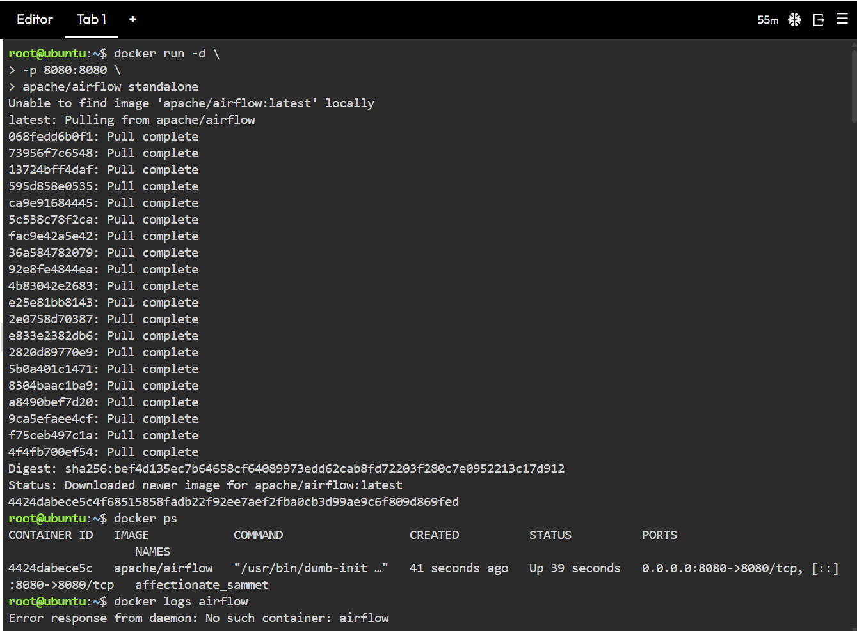
--name airflow \
apache/airflow standalone
- -d runs the container in the background
- --name airflow gives the container the name "airflow"
- apache/airflow standalone pulls the official Airflow image and starts everything in one container including the web server, scheduler, and database

STEP 2 — CHECK THE CONTAINER IS RUNNING
docker ps
This lists all running containers. You should see your airflow container in the list with its status as Up.

STEP 3 — GET THE ADMIN PASSWORD
docker logs airflow
Look through the logs for this line:
Password for user 'admin': XPNtMCcxuacY93WT
This is your login password for the Airflow UI. The username is admin.
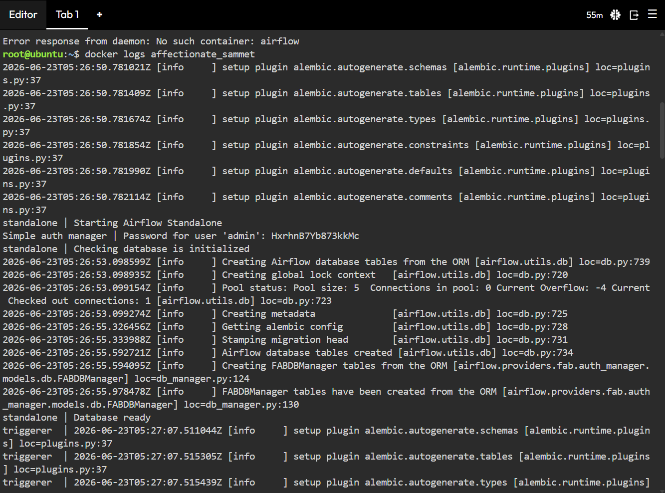

STEP 4 — CLEAR THE SCREEN
clear

STEP 5 — GO INSIDE THE CONTAINER
docker exec -it airflow bash
- docker exec runs a command inside a running container
- -it gives you an interactive terminal
- airflow is the container name
- bash opens a bash shell inside the container
You are now inside the Airflow container.
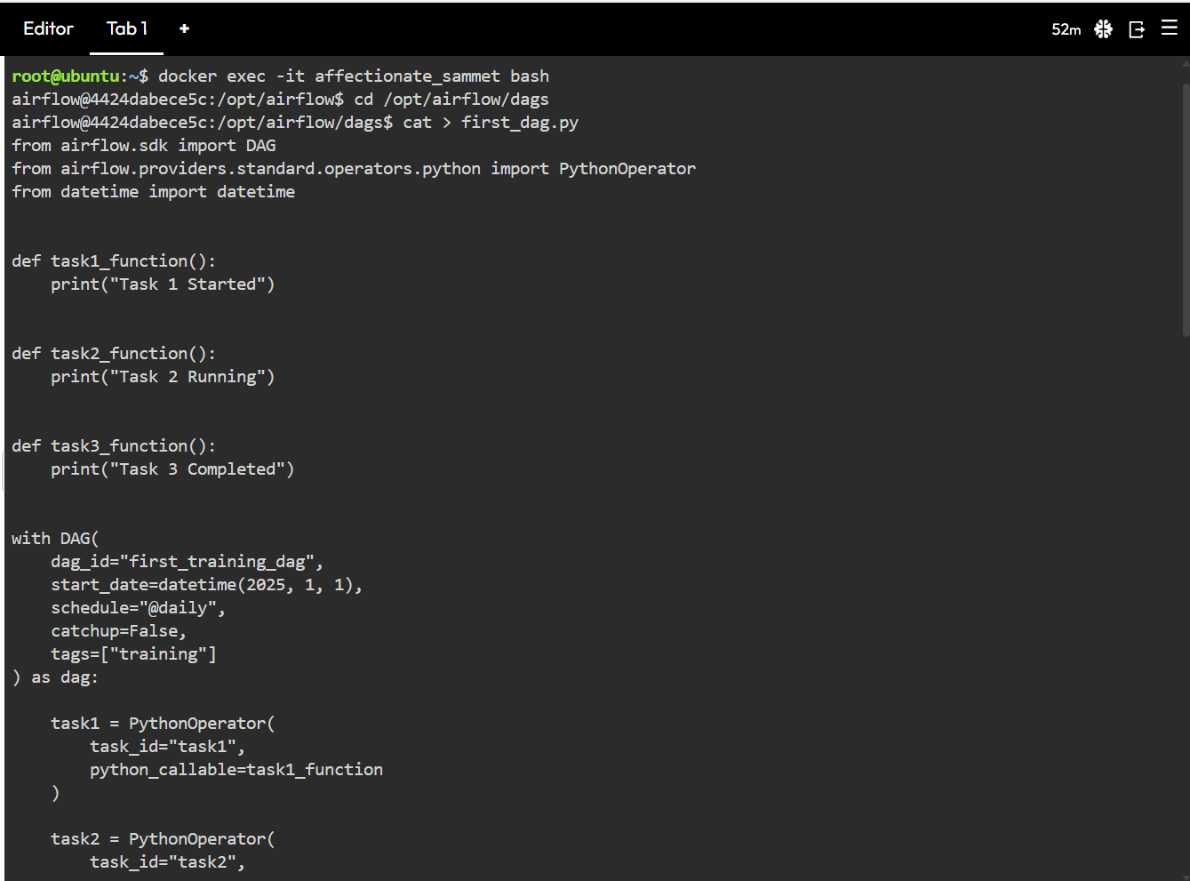

STEP 6 — GO TO THE DAGS FOLDER
cd /opt/airflow/dags
This is where Airflow looks for all DAG files. Any Python file you put here will be picked up by the Scheduler automatically.

STEP 7 — CREATE YOUR FIRST DAG FILE
cat > first_dag.py
Then paste this code:
from airflow.sdk import DAG
from airflow.providers.standard.operators.python import PythonOperator
from datetime import datetime
def task1_function():
print("Task 1 Started")
def task2_function():
print("Task 2 Running")
def task3_function():
print("Task 3 Completed")
with DAG(
dag_id="first_training_dag",
start_date=datetime(2025, 1, 1),
schedule="@daily",
catchup=False,
tags=["training"]
) as dag:
task1 = PythonOperator(
task_id="task1",
python_callable=task1_function
)
task2 = PythonOperator(
task_id="task2",
python_callable=task2_function
)
task3 = PythonOperator(
task_id="task3",
python_callable=task3_function
)
task1 >> task2 >> task3
After pasting press Ctrl + D to save and exit.

WHAT EACH PART MEANS
- dag_id — unique name of your DAG
- start_date — when Airflow starts scheduling it from
- schedule="@daily" — runs once every day
- catchup=False — will not backfill past missed runs
- tags=["training"] — helps filter DAGs in the UI
- task1 >> task2 >> task3 — task1 runs first, then task2, then task3 in sequence

STEP 8 — CONFIRM THE FILE WAS CREATED
ls
You should see first_dag.py listed in the dags folder.
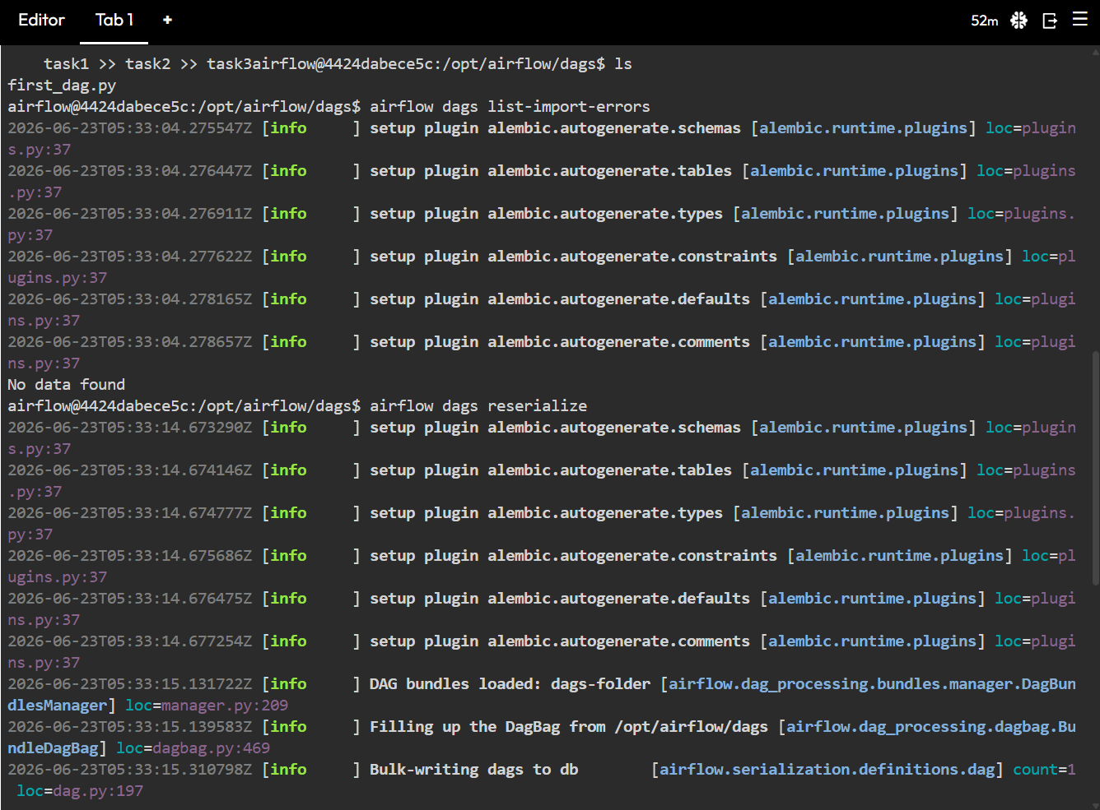

STEP 9 — CHECK FOR IMPORT ERRORS (OPTIONAL)
airflow dags list-import-errors
Checks if your DAG file has any Python errors or import issues. If there are no errors nothing will be shown. Run this if your DAG is not appearing in the UI.

STEP 10 — RESERIALIZE THE DAG
airflow dags reserialize
Forces Airflow to re-read all DAG files and update its internal database. Run this if your DAG is not showing up after creating the file.

STEP 11 — CONFIRM THE DAG IS REGISTERED
airflow dags list
You should see first_training_dag listed here. This confirms Airflow has picked up your DAG file successfully.
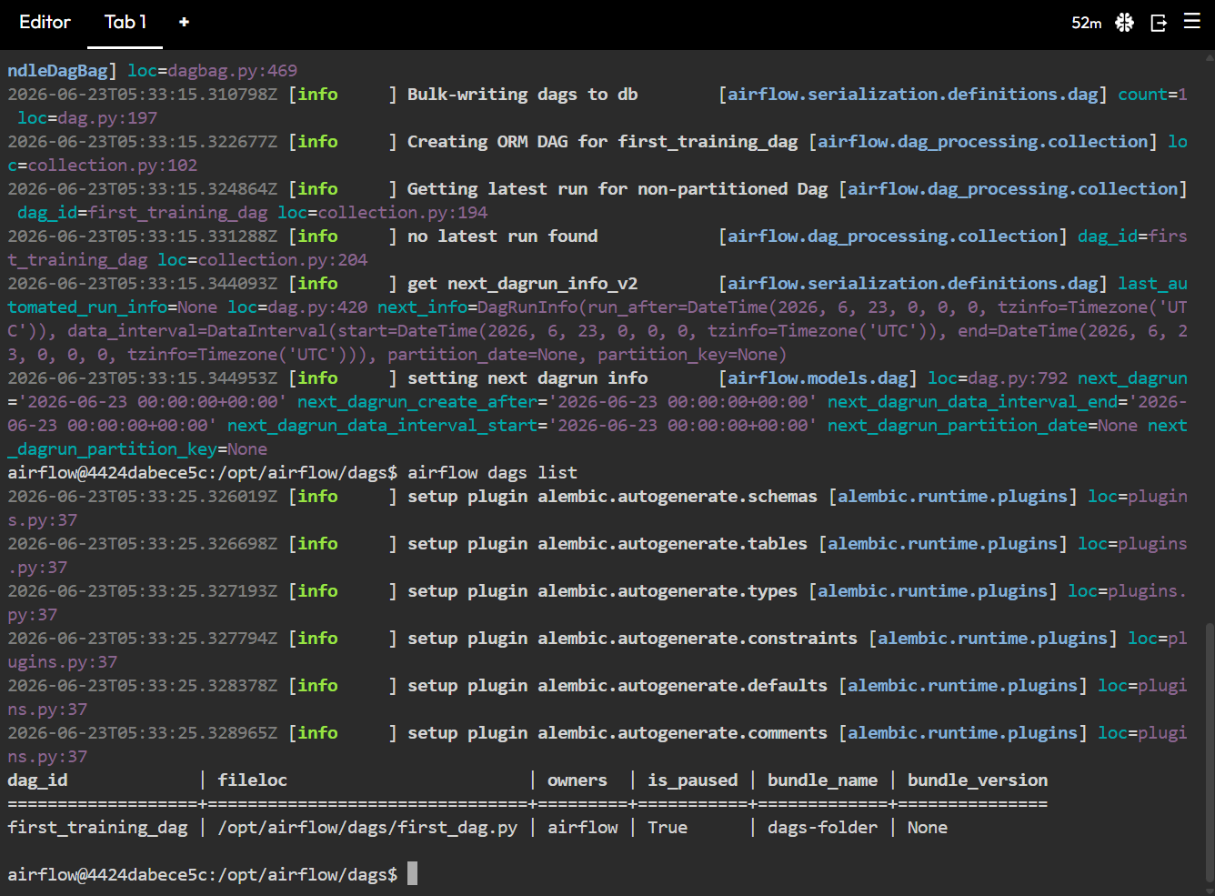

STEP 12 — RUN THE DAG FROM THE UI
- Open the Airflow UI in your browser
- Refresh the page
- You will see first_training_dag in the list
- Click the Toggle button on the left to unpause the DAG
- Click the Trigger button to manually run it
- Click on the DAG name to open it
- Go to Graph view or Grid view to watch the tasks run
- Click on any task then click Logs to see the print output

WHAT HAPPENS WHEN YOU TRIGGER
- task1 runs first and prints "Task 1 Started"
- Once task1 succeeds, task2 runs and prints "Task 2 Running"
- Once task2 succeeds, task3 runs and prints "Task 3 Completed"
- All three tasks turn green in the UI showing success
- The DAG run is marked as success
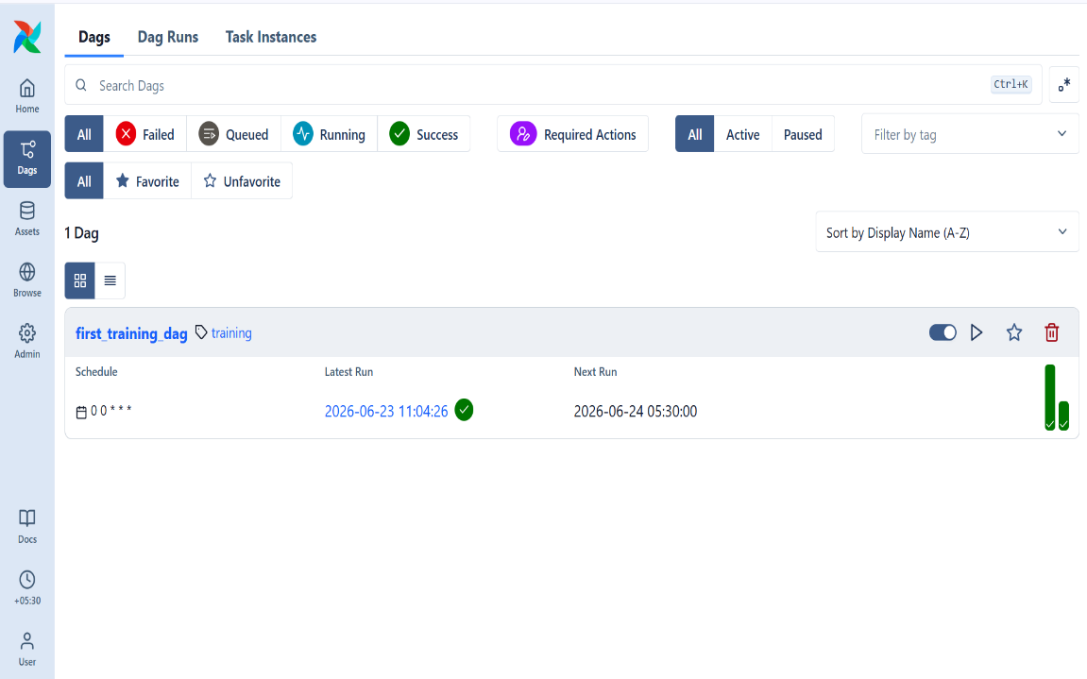

SUMMARY OF ALL COMMANDS
docker run -d --name airflow apache/airflow standalone
docker ps
docker logs airflow
clear
docker exec -it airflow bash
cd /opt/airflow/dags
cat > first_dag.py
ctrl + d
ls
airflow dags list-import-errors
airflow dags reserialize
airflow dags list

